The Montgomery County Hospital District (MCHD) is offering approximately 1,023-square-foot residential structure located at 809 W. Semands Street, Conroe, Texas, for cash sale through sealed bid. Please note that this sale includes the movable structure ONLY. The buyer assumes full responsibility and liability for relocating the building, and no underlying real estate or land is included in the purchase.
Property Description: 1950’s 2 bedroom, 1 full-bath home with composite roof, real hardwood and tile floors.
Kitchen 11 x 12, Living room 22 x 14, Bedroom 1 – 12 x 14, Bedroom 2 – 11 x 14
The addition, not shown in photos, which includes a den and dining area is not included in the sale.
Terms of Sale:
- Condition: The structure is being sold "AS IS" with all faults to be moved from property.
- Removal Responsibility: The successful bidder (Buyer) is solely responsible for all costs associated TxDMV permitting, detaching, lifting, transporting, and relocating the structure.
- Liability: The Buyer assumes full liability for the structure from the moment of bid acceptance and must provide proof of adequate liability and moving insurance before beginning work.
- Site Restoration: The Buyer must clear the property of all debris, utilize bonded/licensed professionals to cut and cap all utilities (water, sewer, gas, electric) below grade, and leave the site in a clean, hazard-free condition, subject to the approval of the City of Conroe inspection standards.
- Payment: Successful bidder has 5 business days to pay and provide proof of TxDMV permitting and scheduled date of move.
- Timeline: The structure must be completely removed from the property, and the site fully restored, no later than 30 days from bid award.

Bid Submittal: Bids must be submitted in writing on the provided using the Bid Proposal Form, signed by the bidder, and enclosed in a sealed envelope marked plainly "SEALED BID – W. SEMANDS STRUCTURE FOR REMOVAL."
All bids must be received no later than 2:00 PM CST on August 6, 2026 at the following address:
Montgomery County Hospital District
ATTN: Melissa Miller, COO
1400 S. Loop 336 W
Conroe, TX 77304

Late, emailed, or faxed bids will not be considered. It is the bidder’s sole responsibility to ensure that the bid is in the possession of MCHD by the deadline.

Reservation of Rights:
The Seller reserves the right to reject any and all bids, to waive informalities or minor irregularities in any bid, and to accept the bid deemed most advantageous to the Seller.
Contact/Inspection:
Property walkthroughs will be held on July 29, 2026 from 8:00 am – 11:30 am.
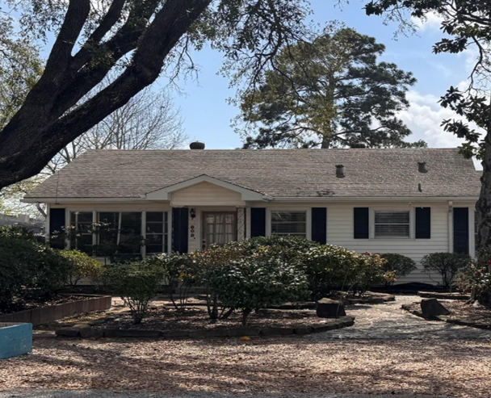
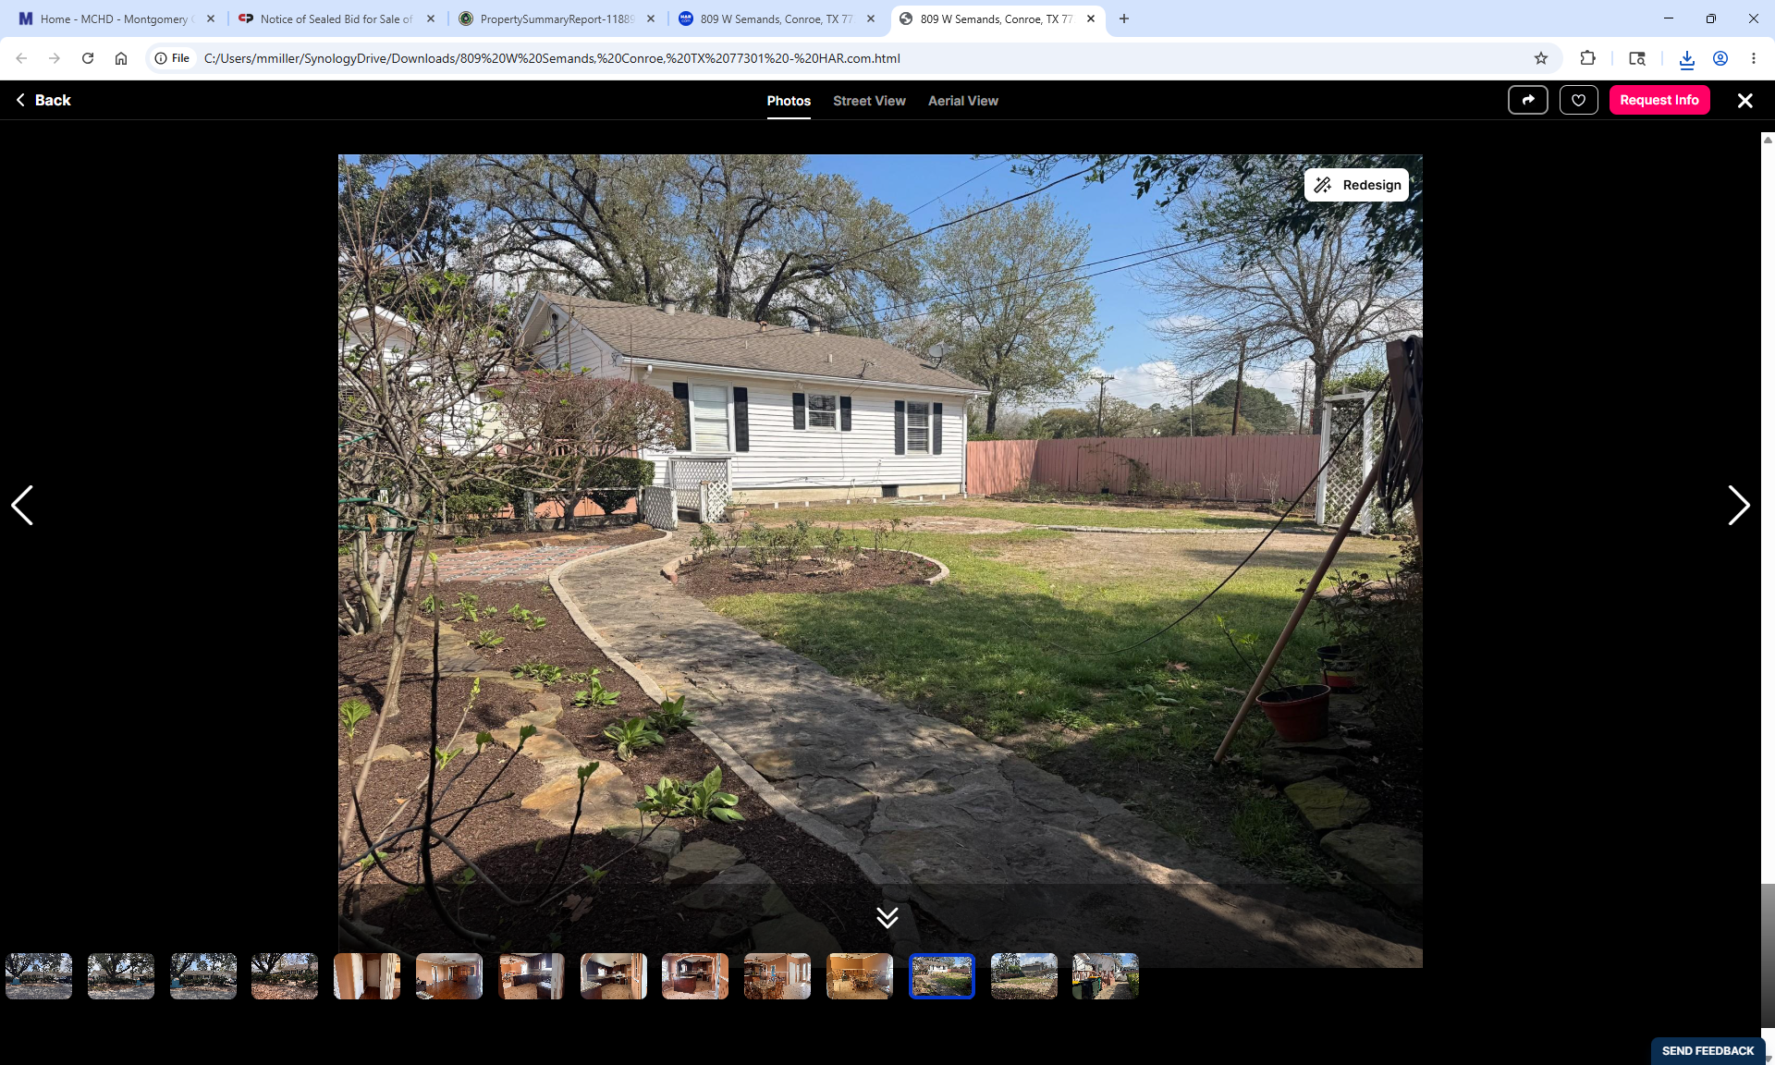

Bid Proposal Form

Structure Address: 809 W. Semands Street, Conroe, TX
Buyer's Name(s): _________________________________________________
Phone Number: _________________________________________________
Email Address: _________________________________________________
Mailing Address: _________________________________________________
Financial Offer:
I/We hereby offer to purchase the referenced structure for the total cash price of:
Numerical Amount: $____________________
Written Amount: ________________________________________________
Payment:
I understand that if I am the successful bidder, I am required to pay by cash in full $____________________ within 5 business days of bid acceptance.

Bidder Certification:
I certify that I have read and agree to all the terms and conditions outlined in the Invitation for Sale by Sealed Bid. I understand that this is a legally binding offer and cannot be withdrawn prior to the formal bid opening.
Signature: ____________________________________ Date: _____________

